Interactive Data Story Plan

Week 3 Task – Sales Performance & Growth Opportunities
Prepared by: Mukesh Samarit
Course / Module: Virtual Tableau Visualization Intern
Date: 29 August 2026

1. Data Story Concept

1.1 Context
The marketing manager needs to drive sales growth by focusing efforts on the right regions and product categories. At the same time, they must identify and fix performance bottlenecks—such as slow delivery, low customer ratings, or excessive discounting—that are hurting customer experience and profitability.

1.2 Core Narrative
This data story communicates two key messages:
- Where are we performing well, and where do we need to fix issues so that marketing focus lands in the right places?
- Which region × product combinations represent high risk and which represent high opportunity?
The story guides the marketing manager from a high-level view of sales performance down to specific region × category actions.

1.3 Target Audience
- Primary Audience: Marketing Manager
  - Uses the story to decide where to run campaigns, promotions, and operational improvement initiatives.
- Secondary Audience: Marketing Analysts, Sales/Operations Leads
  - Use the story to understand priorities and align on actions (e.g., delivery improvements, pricing changes).

1.4 Key Insights the Story Will Reveal
- Overall sales performance and trend over time.
- Which regions and product categories are driving revenue?
- Where bottlenecks exist (high discount, slow delivery, low rating).
- Which region × category combinations are:
  - High Opportunity: High revenue, good rating, reasonable discount.
  - High Risk: Low rating, slow delivery, heavy discount, or falling revenue.
- Specific areas to push (invest more) and to fix (improve operations/pricing).

2. Visual Narrative Planning
The story will be told in 5–6 scenes, each represented by one main visualization or view. The sequence is designed to be logical and easy to follow.

Scene 1: Opening – “Where Are We Now?” (Overview)
Visualization: KPI Summary + Context Text
- Show 5 KPI cards:
  - Total Revenue
  - Avg Order Value
  - Avg Discount
  - Avg Delivery Days
  - Avg Customer Rating
- Add a short text box:
  - “This story helps identify high-risk and high-opportunity regions and product categories to prioritize marketing and operational actions.”
Contribution to Story:
- Sets the stage by showing current performance.
- Answers: “How are we doing overall?”
- Gives context before diving into details.

Scene 2: Trend – “Are We Improving or Declining?”
Visualization: Line Chart – Revenue by Month
- X-axis: Month (from order_date)
- Y-axis: Revenue
- Tooltip: Revenue, Order Count, Avg Discount, Avg Delivery Days, Avg Rating.
Contribution to Story:
- Shows direction over time: growth, decline, or seasonality.
- Helps answer: “Is performance improving or getting worse?”
- Prepares the user to understand whether risks are new or ongoing.

Scene 3: Breakdown – “Where Is Performance Different?”
Visualization: Two Bar Charts (side by side or sequential)
- Revenue by Region
- Revenue by Product Category
Contribution to Story:
- Highlights which regions and categories contribute most (and least) to revenue.
- Answers: “Where are the big differences in performance?”
- Sets up the next scene, where we examine why these differences exist.

Scene 4: Risk & Bottleneck – “Where Are the Problems?”
Visualization: Scatter Plot – Avg Delivery Days vs Avg Customer Rating
- Each point = Region × Product Category
- X-axis: Avg Delivery Days
- Y-axis: Avg Customer Rating
- Size: Revenue
- Color: Region or Product Category
- Tooltip: Revenue, Avg Discount, Avg Delivery Days, Avg Rating, Order Count.
Contribution to Story:
- Visually separates:
  - High Risk: Slow delivery + low rating (bottom-right).
  - High Opportunity: Fast delivery + high rating + good revenue (top-left / top-right with large size).
- Answers: “Which region × category combinations are risky, and which are strong?”
- Makes bottlenecks obvious in one view.

Scene 5: Deep Dive – “What Exactly Is Happening?”
Visualization: Detail Table – Region × Product Category
- Rows: Region × Product Category
- Columns:
  - Revenue
  - Order Count
  - Avg Discount
  - Avg Delivery Days
  - Avg Customer Rating
Contribution to Story:
- Provides specific numbers for each combination.
- Allows sorting (e.g., by Avg Delivery Days or Avg Rating) to find worst and best performers.
- Answers: “Exactly which areas need action, and what are their metrics?”

Scene 6 (Optional): Action Summary – “What Should We Do Next?”
Visualization: Highlighted Top 5 Risks + Top 5 Opportunities (can be a filtered view of the table or two small bar charts).
- Top 5 Risks: Highest delivery days + lowest ratings.
- Top 5 Opportunities: High revenue + high rating + moderate/low discount.
Contribution to Story:
- Turns insights into clear recommendations.
- Answers: “What should the marketing manager prioritize this month/quarter?”
Agar tum simple rakhna chahte ho to Scene 6 ko table ke andar hi “sort & highlight” ke through handle kar sakte ho, alag view na banao.

3. Interactive Elements and How They Support the Story
Interactive features allow the user to explore the narrative in more depth, while still following the main story flow.

3.1 Global Filters
Filters:
- Relative Date Filter:
  - Options: Last 3 months, Last 6 months, YTD, Last 12 months.
  - Impact: All scenes update to reflect selected time period.

- Region (Multi-select):
  - Allows focusing on specific regions (e.g., only North and West).

- Product Category (Multi-select):
  - Allows focusing on specific categories (e.g., Electronics, Furniture).

- Payment Method (Multi-select):
  - Optional, but helps see if certain payment types correlate with delivery or rating issues.
How They Support the Narrative:
- Let the marketing manager tailor the story to their current focus (e.g., “Show me only Electronics in North region for the last 6 months”).
- Ensure the story remains relevant for different segments without creating multiple dashboards.

3.2 Navigation / Story Flow Control
Approach: Use Tableau’s Story feature or a single dashboard with guided navigation.
Options:
- Tableau Story (Recommended for this task):
  - Each scene = one “story point”.
  - User clicks “Next” to move from Scene 1 → Scene 2 → … → Scene 6.
  - Each story point highlights the relevant visualization and adds a short caption explaining the insight.
- Single Dashboard with Section Navigation (Alternative):
  - Use buttons or parameters to “jump” to sections (Overview, Trend, Breakdown, Risk, Detail).
  - More advanced, but keeps everything in one view.
For this assignment, Tableau Story approach is clearer and matches the “sequential and logical manner” requirement.
How It Supports the Narrative:
- Enforces a logical sequence: overview → trend → breakdown → risk → detail → action.
- Prevents users from getting lost in too many charts at once.
- Makes the data story feel like a guided presentation, not just a static dashboard.

3.3 Dashboard Actions (Filter & Highlight)
Interactions:
- Click on Region Bar (Scene 3):
  - Filters all subsequent scenes (Scatter Plot, Detail Table) to that region.
  - Helps answer: “What is happening specifically in this region?”
- Click on Product Category Bar (Scene 3):
  - Filters all subsequent scenes to that category.
- Hover on Scatter Plot Points (Scene 4):
  - Shows rich tooltip with Revenue, Avg Discount, Avg Delivery Days, Avg Rating, Order Count.
  - No click filtering (to avoid over-filtering), just detailed hover info.
- Sort Detail Table (Scene 5):
  - User can sort by:
    - Avg Delivery Days (to find slowest regions).
    - Avg Rating (to find lowest satisfaction).
    - Revenue (to find biggest opportunities).
How They Support the Narrative:
- Allow deeper exploration without breaking the main story flow.
- Let the marketing manager answer follow-up questions like:
  - “What is happening in North region specifically?”
  - “Which categories have the worst delivery times?”
- Make the story interactive, not just a linear slideshow.

3.4 Parameters (Optional but Powerful)
If you want to show extra interactivity in your plan:
- Metric Selector Parameter:
  - Options: Revenue, Avg Discount, Avg Delivery Days, Avg Rating.
  - Used in the detail view to color-code the table or bars based on selected metric.
- Risk Threshold Parameter:
  - Example: “Show me region × category combinations where Avg Delivery Days > X”.
  - Helps focus on severe bottlenecks.

4. Story Flow Diagram (To Be Created in PowerPoint)
This diagram shows the sequence of scenes in the data story.

4.1 Diagram Content (Boxes + Arrows)
Create a simple flowchart in PowerPoint with 6 boxes connected by arrows:
- Box 1: Scene 1: Overview – KPI Summary
- Box 2: Scene 2: Trend – Revenue by Month
- Box 3: Scene 3: Breakdown – Revenue by Region & Category
- Box 4: Scene 4: Risk & Bottleneck – Delivery vs Rating Scatter Plot
- Box 5: Scene 5: Deep Dive – Detail Table (Region × Category)
- Box 6: Scene 6: Action Summary – Top Risks & Opportunities
Connect them with arrows:
- Scene 1 → Scene 2 → Scene 3 → Scene 4 → Scene 5 → Scene 6
Add a title above the diagram:
- Figure 1: Data Story Flow – Sales Performance & Growth Opportunities
Export this as PNG and insert it below.

4.2 How to Include in the DOC
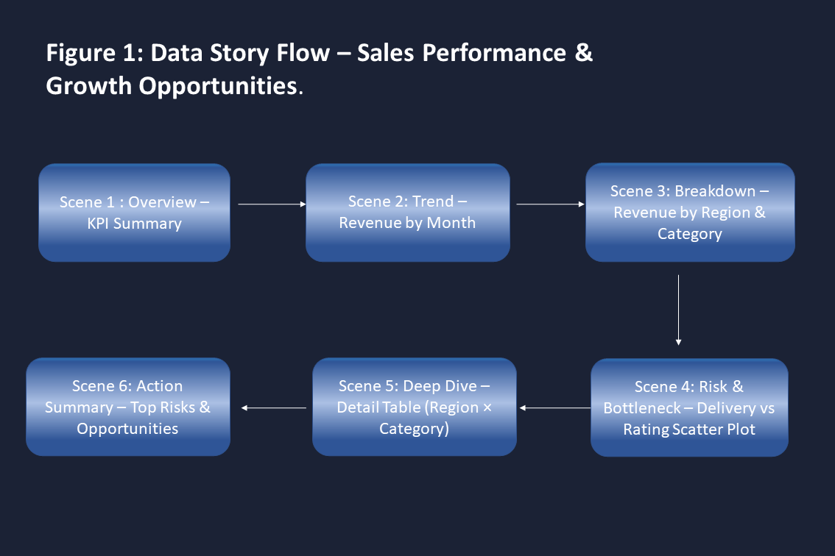
Figure 1: Data story flow showing the sequence of scenes from overview to action.
Figure 1 shows the sequence of scenes in the data story. The user starts with an overview of key metrics, then moves through trend, breakdown, risk, and detail views, ending with a clear set of priorities for action. This flow ensures a logical and engaging narrative that guides the marketing manager from insight to decision.

5. How This Story Meets the Evaluation Criteria

5.1 Coherence and Clarity of Narrative Design
- Clear beginning (overview), middle (trend, breakdown, risk), and end (detail + action).
- Each scene has a specific question it answers.
- Flow diagram makes sequence explicit.

5.2 Innovative Use of Interactive Elements
- Global filters let users customize the story.
- Click-to-filter interactions connect breakdown to risk and detail views.
- Tooltips provide rich context without clutter.
- Optional parameters add advanced exploration.

5.3 Depth of Analysis and Planning
- Story is directly tied to business problem and audience needs.
- Each visualization has a defined role in the narrative.
- Interactions are mapped to specific user questions.

5.4 Ability to Convey a Complete and Engaging Data Story
- Starts with “Where are we now?”
- Moves to “Are we improving?” → “Where are differences?” → “Where are problems?” → “What exactly is happening?” → “What should we do?”
- Ends with actionable priorities, not just charts.

6. Implementation Notes (Brief)
- Tool: Tableau (using Story feature or guided dashboard).
- Data Source: Same CSV/Excel as Week 2:
  - order_id
  - order_date
  - customer_id
  - product_category
  - region
  - quantity
  - unit_price
  - discount
  - payment_method
  - delivery_days
  - customer_rating
  - revenue.
- Refresh Frequency: To be defined (e.g., weekly or monthly).
- Performance Considerations:
  - Use aggregations for KPIs and charts.
  - Limit detail table to top N or filtered subsets if data grows large.

